**Ideation Phase**

**Define the Problem Statements**

|  |  |
| --- | --- |
| Date | 31 January 2025 |
| Team ID | LTVIP2025TMID48259 |
| Project Name | Plugging into the Future: An Exploration of Electricity Consumption Patterns using Tableau |
| Maximum Marks | 2 Marks |

**Customer Problem Statement Template:**

Create a problem statement to understand your customer's point of view. The Customer Problem Statement template helps you focus on what matters to create experiences people will love.

A well-articulated customer problem statement allows you and your team to find the ideal solution for the challenges your customers face. Throughout the process, you’ll also be able to empathize with your customers, which helps you better understand how they perceive your product or service.

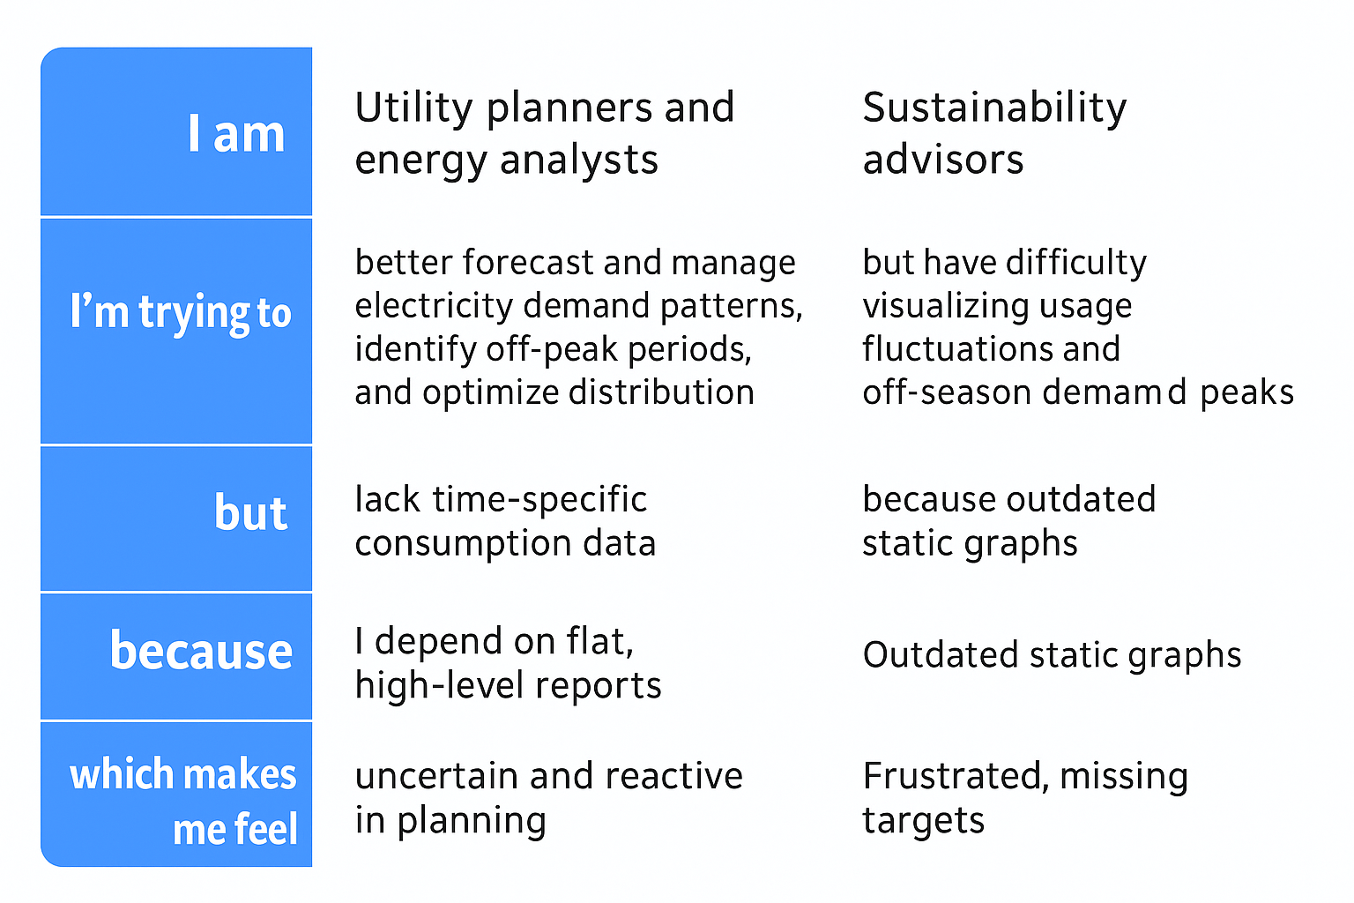

|  |  |  |  |  |  |
| --- | --- | --- | --- | --- | --- |
| **Problem Statement (PS)** | **I am (Customer)** | **I’m trying to** | **But** | **Because** | **Which makes me feel** |
| PS-1 | an energy analyst working at a utility company | understand how electricity is being consumed across different sectors and regions throughout the day | I struggle with fragmented data and lack of visual tools to compare usage trends and peaks | current reports are not interactive and don’t show time-of-day or seasonal breakdowns | frustrated and unable to plan for demand effectively |
| PS-2 | a policymaker working on energy sustainability strategies | identify which sectors are over-consuming electricity and plan energy-saving initiatives | I lack clear visual insights into seasonal variations and sector-specific trends | data is scattered across formats and not optimized for planning | uncertain about policy effectiveness and resource planning |

2.2 Empathy map

